**Name: Zishnendu Sarker**

**Roll: 2K19/CO/450**

**Subject : Java Lab**

**Group : G3**

**Date :26/08/2021**

**LAB ASSIGNMENT 01**

**1. Java program to find ASCII value of a character**

**Code:**

public class AsciiValue

{

public static void main(String[] args)

{

char ch = 'a';

int ascii = ch;

int castAscii = (int) ch;

System.out.println("The ASCII value of " + ch + " is: " + ascii);

System.out.println("The ASCII value of " + ch + " is: " + castAscii);

}

}

**Output:**

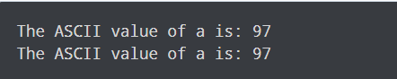

**2. Java Program to Compute Quotient and Remainder**

**Code:**

public class QuotientRemainder

{

public static void main(String[] args)

{

int dividend = 25, divisor = 4;

int quotient = dividend / divisor;

int remainder = dividend % divisor;

System.out.println("Quotient = " + quotient);

System.out.println("Remainder = " + remainder);

}

}

**Output:**

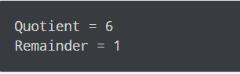

**3. Java Program to Swap Two Numbers**

**Code:**

public class SwapNumbers

{

public static void main(String[] args)

{

float first = 1.20f, second = 2.45f;

System.out.println("--Before swap--");

System.out.println("First number = " + first);

System.out.println("Second number = " + second);

float temporary = first;

first = second;

second = temporary;

System.out.println("--After swap--");

System.out.println("First number = " + first);

System.out.println("Second number = " + second);

}

}

**Output:**

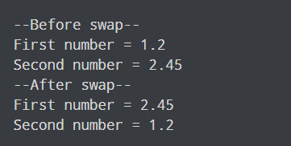

**4. Java Program to Check Whether a Number is Even or Odd**

**Code:**

import java.util.Scanner;

public class EvenOdd

{

public static void main(String[] args)

{

Scanner reader = new Scanner(System.in);

System.out.print("Enter a number: ");

int num = reader.nextInt();

if(num % 2 == 0)

System.out.println(num + " is even");

else

System.out.println(num + " is odd");

}

}

**Output:**

